Kimberly Kuya

**Practical Activity Week 3**

**Part 1**

Perform the following activities and screenshot your output from Ubuntu- Terminal.

1. List the processes for the current shell. 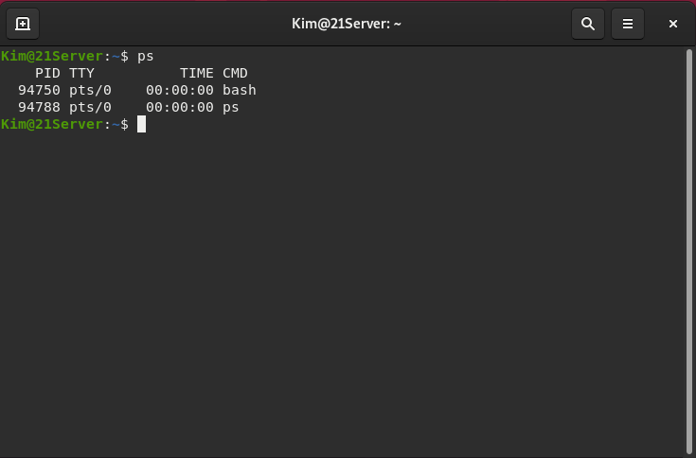
2. Display information about processes. 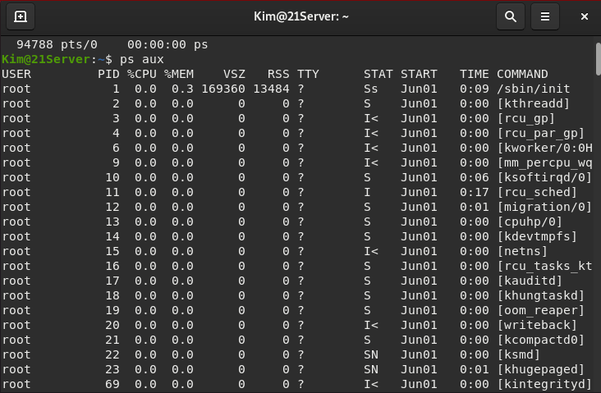
3. Display the global priority of a process and find out the column that provides. 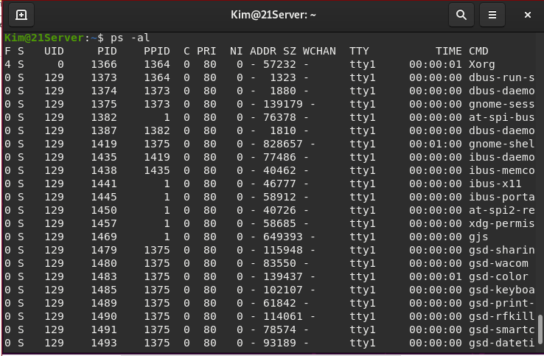
4. Change the priority of a process with default arguments. 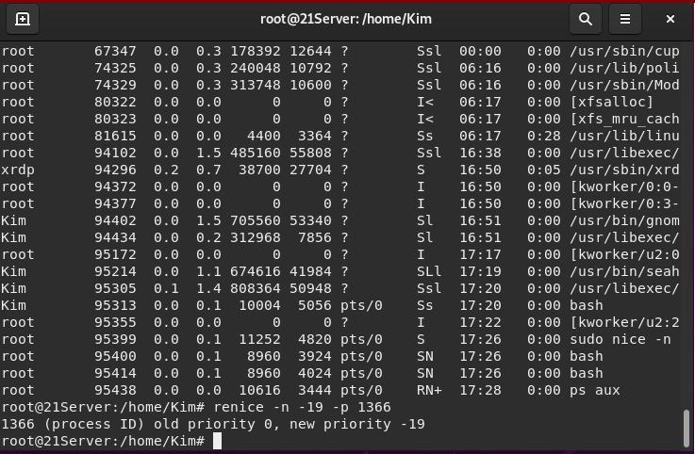
5. Display Virtual Memory Statistics. 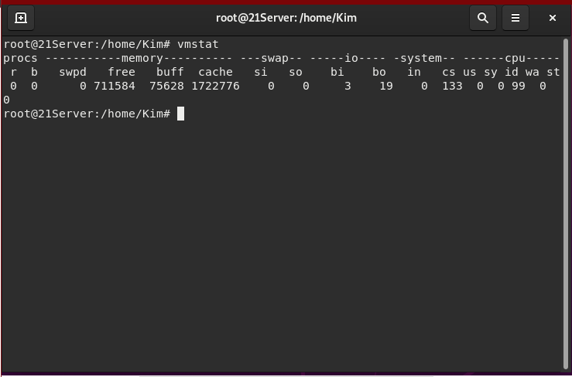
6. Display System Event Information. 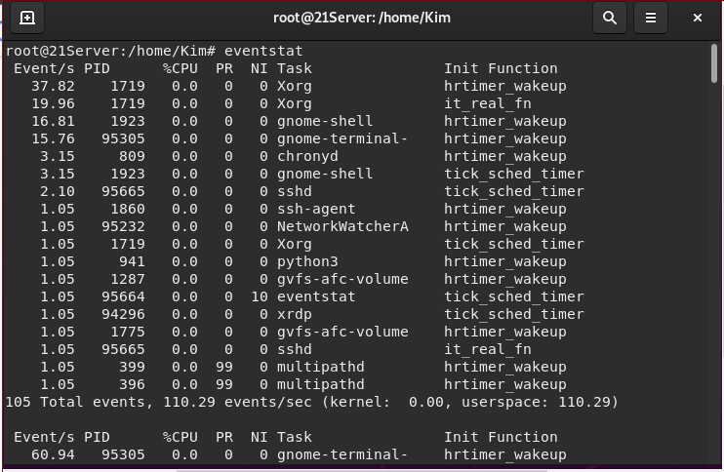
7. Display Swapping Statistics. 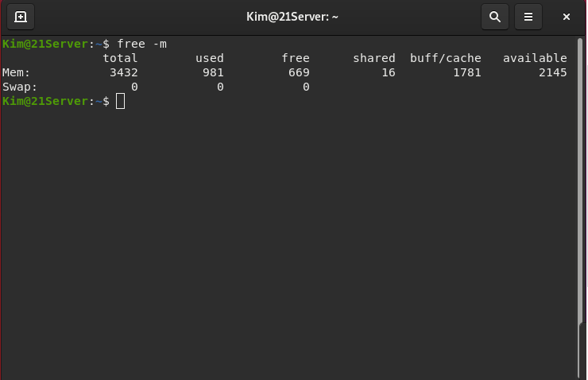
8. Check File Access statistics. 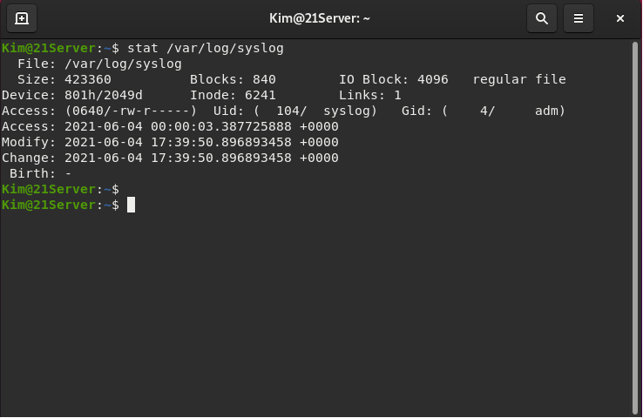
9. Check Buffer Activity statistics. 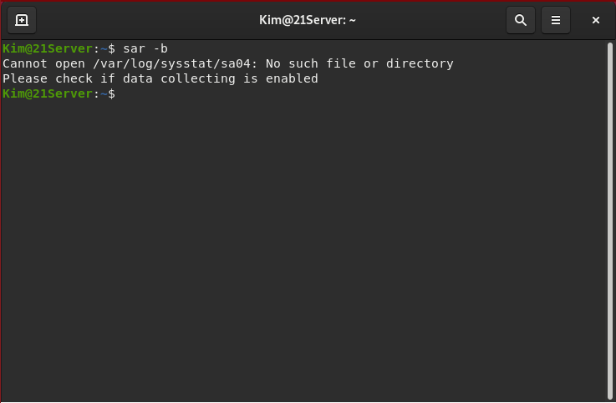
10. Check Disk Activity statistics. 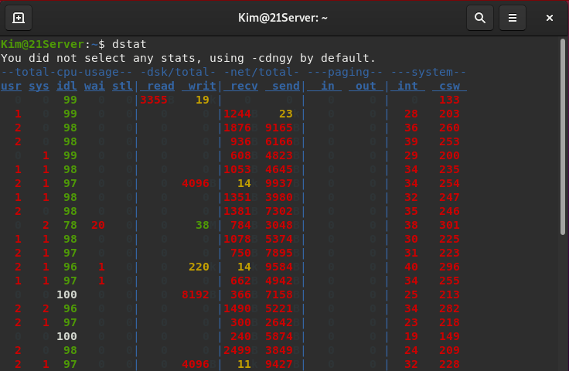
11. Check Inter process Communication statistics. 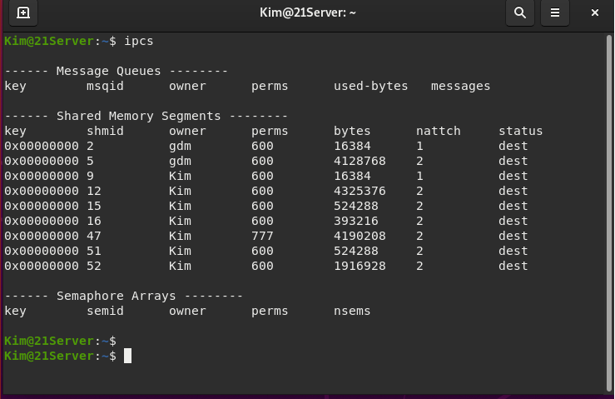
12. Check Unused Memory in the server. 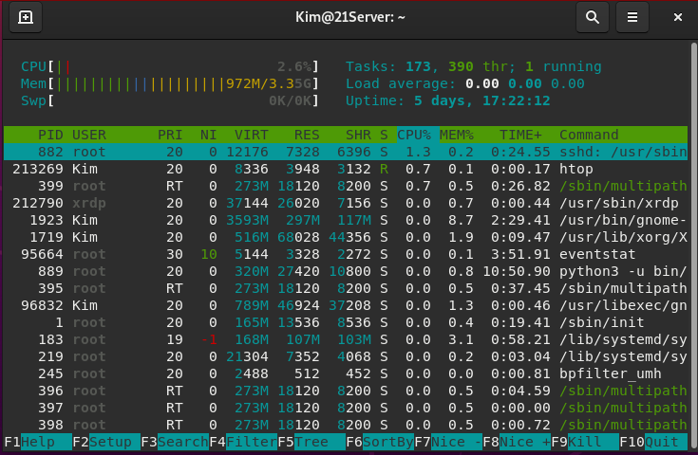
13. Check Swap Activities. 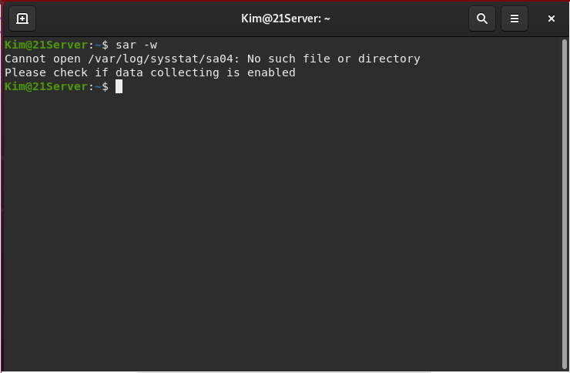

**Practical Activity Part 2**